CMSC 315

Programming Project 3 – Binary Search Trees

Daniel Smolsky

**UML Diagram:**

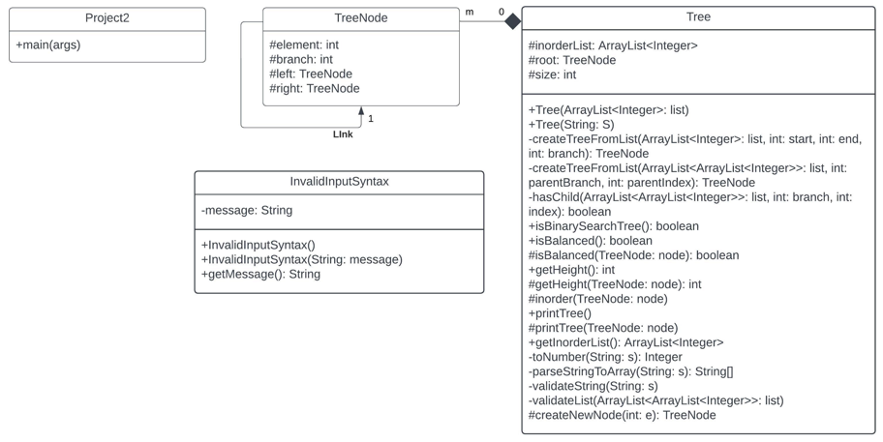

**Test Plan:**

|  |  |  |  |  |  |
| --- | --- | --- | --- | --- | --- |
| Test # | Purpose | Pos/Neg Test | Input Values | Expected Result | Pass/Fail |
| 1 | Check program output matches examples | Pos | (53 (28 (11 * *) (41 * *)) (83 (67 * *) *))  (63 (51 (20 (13 * *) *) *) *)  (13 (53 * *) (11 (59 * *) *)) | Same as program guidelines | pass |
| 2 | Check invalid string inputs return exceptions with description of the issue | Pos | (53 (28 (11 * *) (41 * *)) (83 (67 * *))) | Branch 2 is missing nodes | pass |
| 3 | Check invalid string inputs return exceptions with description of the issue | Pos | (53 (28 (11 * *) (41 * *)) (83 (r * *) *)) | Data is not an integer | pass |
| 4 | Check invalid string inputs return exceptions with description of the issue | Pos | (63 (51 (20 (13 * *) *) *) * | Missing right parenthesis | pass |
| 5 | Check trees with no left subtrees are draw correctly | Pos | (53 * (83 (67 * *) *)) | Unbalanced tree is drawn | pass |

Test plan 1:

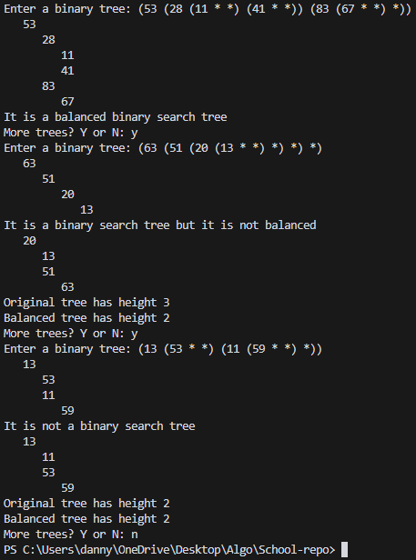

Test plan 2:



Test plan 3:  


Test plan 4:  


Test plan 5:  
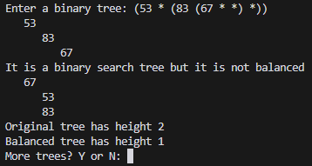

**Lessons Learned:**

Most of the methods in my tree class were recursive, and originally it was hard to follow the stack execution as recursive methods would call other recursive methods. I significantly improved on my recursive logic programming skills due to this, and as a result my binary search tree creation process is clean and efficient. Additionally, I improved on my exception handling, string parsing and validation, and documentation skills. One goal I had for this project was for my code to be easily understandable by someone looking at it their first time, and I feel due to all of the descriptive comments I’ve accomplished this.